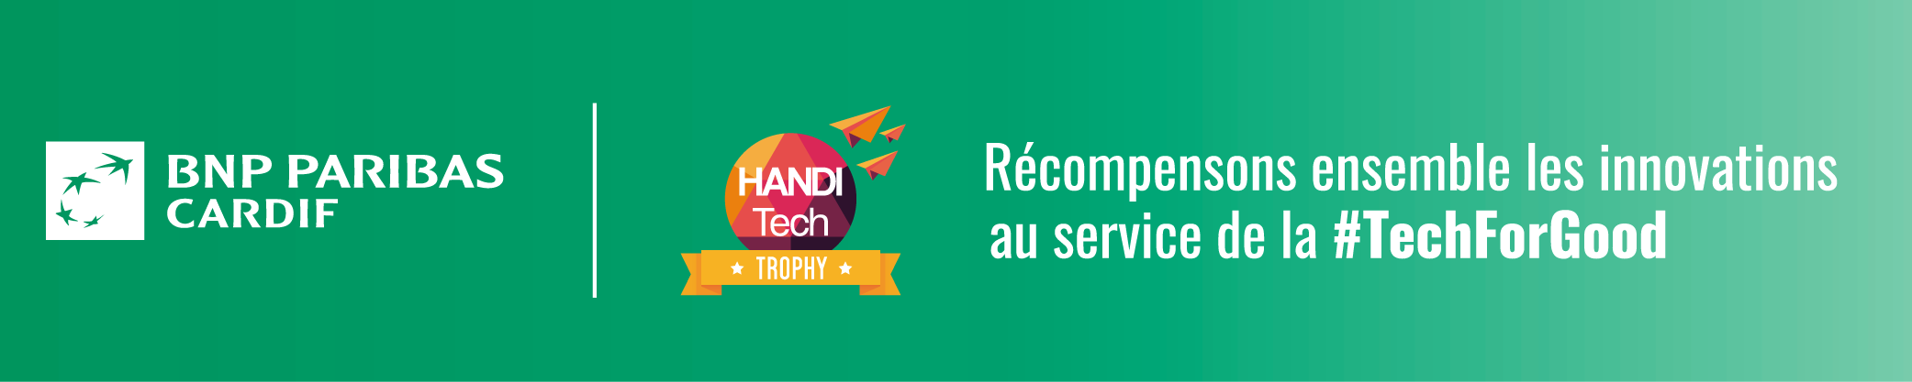Paris, 14/11/2019

BNP Paribas Cardif renews partnership with HandiTech Awards

The 2019 HandiTech Awards will be presented on 18 November to kick off European Disability Employment Week. The awards recognize entrepreneurs who develop technologies to improve the lives of people with disabilities. BNP Paribas Cardif, a global specialist in personal insurance committed to making insurance accessible to the largest possible number of people, will present the award for the best initiative in the healthcare category. BNP Paribas Cardif is sponsoring the HandiTech Awards for the second consecutive year, underscoring the insurer’s longstanding support for innovation that drives a more inclusive world.

Make insurance accessible to the largest possible number of people: a future-facing mission

The values and strategy of BNP Paribas Cardif are inspired by the insurer’s commitments. BNP Paribas Cardif strives to facilitate access to its products to enable everyone to make their projects become reality. Ten percent of the world’s population is affected by disabilities, representing 650 million people. BNP Paribas Cardif continually enhances its insurance cover and services, reduces the number of exclusions and simplifies the insurance subscription process in order to expand access to insurance for vulnerable members of society who have a disability or suffer from a disease. Thanks to this approach the insurer contributes to greater solidarity in society.

Innovation drives inclusion

Technological advances in areas such as artificial intelligence, robotics or digital technologies allow BNP Paribas Cardif to increase the granularity of insurance policies and create new offers that are continually better matched to the needs of its clients, including the most vulnerable among them.

In France, clients enjoy terms that facilitate access to creditor insurance. BNP Paribas Cardif introduced further innovations this year with its Cardif Libertés Emprunteur offer, which now proposes insurance cover and rates adapted to four additional pathologies: Parkinson’s disease, obesity, gestational diabetes and mental health issues related to a life event. Furthermore, in line with its diversity and inclusion policy, BNP Paribas Cardif supports the “Tangata.net” intrapreneurial project. This digital platform lists a broad selection of verified partners, providing access to a large number of leisure activities accessible to people with disabilities and adapted services to facilitate the daily lives of people with disabilities and their caregivers. Tangata.net also aims to accelerate the development of entrepreneurs and partner associations with the Act for Impact social entrepreneurship brand of BNP Paribas.

With a presence in 35 countries and a unique business model based on partnerships, BNP Paribas Cardif carries out numerous initiatives related to disabilities. In Taiwan, the insurer has set up a home visit service to make it easier for policyholders with disabilities to file claims. In Germany, a temporary disability assistance service helps clients in their day-to-day activities (advice, contacts for medical service providers, educational campaigns for drugs and treatments). And in Turkey, the Engelsiz Hayat Değer life insurance policy has been designed for families that have children with disabilities. It includes assistance services (reduced costs for medication, hospitalisation, physical therapy, etc.) in order to ease their lives.

Renaud Dumora, Chief Executive Officer of BNP Paribas Cardif: “We are extremely proud to once again partner with the HandiTech Awards. Being part of this event reflects our commitment to leveraging innovation in order to improve the living conditions of people affected by disabilities. Through this initiative BNP Paribas Cardif supports innovative entrepreneurs who work to build a more inclusive and more sustainable world.”
___________________________________________
SAVE THE DATE
Monday 18 November, Handitech Trophy awards ceremony.
@LaHanditech_ avec le #HTT19
Lahanditech

Follow the entire event on

Read a special report published in the 19 November issue of

About BNP Paribas Cardif
The world leader in creditor insurance, BNP Paribas Cardif plays an essential role in the lives of its policyholder clients, providing them with savings and protection solutions that let them realize their goals while protecting themselves from unforeseen events. As a committed insurer, BNP Paribas Cardif works to have a positive impact on society and to make insurance accessible to the largest possible number of people. In a world that has been deeply transformed by the emergence of new uses and lifestyles, the company, a subsidiary of BNP Paribas, has a unique business model anchored in partnerships. It co-creates solutions with almost 500 partner distributors in a variety of sectors (including banks and financial institutions, automotive sector companies, retailers, telecommunications companies, energy companies…) and financial advisors and brokers who market the products to their customers. BNP Paribas Cardif is a global specialist in personal insurance, serving 100 million clients in 35 countries with strong positions in three regions – Europe, Asia and Latin America – and plays a major role in providing financing for the economy. With nearly 10,000 employees worldwide, BNP Paribas Cardif had gross written premiums of €31.8 billion in 2018.
Follow the latest news about BNP Paribas Cardif on

More information

BNP PARIBAS CARDIF
Marion Saraf
Relations Presse
marion.saraf@bnpparibas.com

HANDITECH TROPHY
Carla Sinacori
Chef de projet web éditorial
csinacori@jobinlive.fr

WHO figures - 2013
Source: Finaccord - 2018

